CSC 395-02 Advanced Swift App Development with ARKit
━━━━━━━━━━━━━━━━━━━━━━━━━━━━━━
Michael Amoo
Hampton University
Instructor: Dr. Chutima Boonthum-Denecke
Midterm Project
October 12, 2026

1. Introduction
For my CSC 395 midterm project, I created StudyLens, a study application built with SwiftUI for macOS and iOS. I wanted the app to solve a problem I run into when studying from different kinds of material. My notes can come from typed text, handwriting, screenshots, scanned pages, documents, or things I say out loud. Instead of keeping those materials separate, StudyLens gives me one place to capture them, save them, and turn them into something I can study from.
StudyLens uses native Apple frameworks for most of its work. SwiftData stores notes on the device. Vision handles text recognition from scanned images and handwriting. PencilKit provides the handwriting canvas. Speech and AVFoundation support dictation and spoken study material. Apple's Foundation Models framework is the main generative AI feature and turns selected notes into a structured study guide. That same result is reused by Quiz Me, Flashcards, and the Brain Map instead of asking the model to generate the same material again.
I also added Wikipedia as an optional external information source. Wikipedia is not mixed into the study guide automatically. The app only looks up a concept after the user chooses Learn More. The student can then decide whether the information is useful enough to save as a new note.
A large part of the project was built through agentic coding inside Xcode. I developed the app in stages, reviewed the generated code, tested each feature, and used later prompts to fix problems that appeared as the project grew. The full process is recorded in AgenticCodingLog.txt.
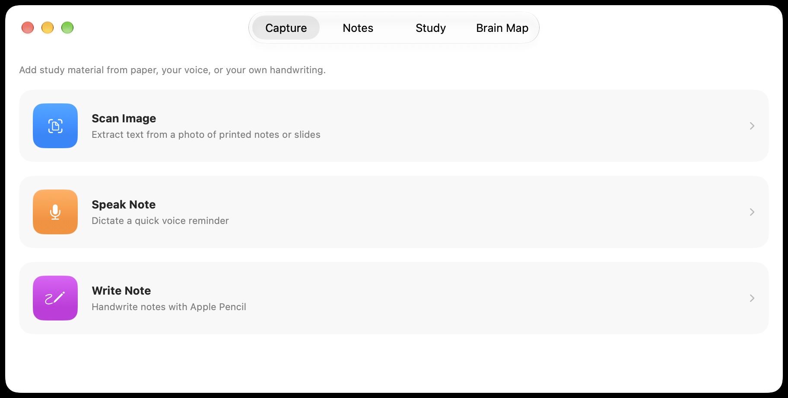

2. Design and AI APIs
StudyLens is organized around four tabs: Capture, Notes, Study, and Brain Map. Capture brings information into the app. Notes stores and manages the saved material. Study turns a chosen set of notes into review material. Brain Map gives the generated concepts a visual form. This separation kept the interface simple while the code behind each section became more advanced.
The code follows a Model, View, ViewModel, and Service style structure. Models define data such as notes, study guides, flashcards, imported files, and Wikipedia results. ViewModels manage screen state and user actions. Services handle heavier work such as OCR, speech recognition, study guide generation, file importing, exporting, and Wikipedia requests. AppNavigationModel owns the main navigation state so the tabs do not create conflicting navigation stacks.
Framework / API | Role in StudyLens
SwiftUI | Interface, navigation, sheets, controls, and accessibility
SwiftData | Persistent note storage
Foundation Models | On-device study guide generation and model-based quiz grading
Vision | OCR for scans, handwriting images, and image-based PDF pages
PencilKit | Handwritten note canvas
Speech / AVFoundation | Dictation, spoken answers, and text-to-speech
PDFKit | Reading PDF text and rendering pages for OCR
Foundation / URLSession | Wikipedia networking and JSON decoding

2.1 Main AI Feature: Apple Foundation Models
The main AI API in StudyLens is Apple's Foundation Models framework. I used it to generate study material from notes already saved inside the app. The model is not used as a general chatbot. The user chooses the study source, and only that selected material is sent to the model.
All Foundation Models logic is kept in StudyAnalysisService.swift. The service checks whether the system model is available, prepares the selected notes, creates grounding instructions, starts a LanguageModelSession, and returns a structured StudyAnalysis. Keeping this work out of the SwiftUI views made the AI path easier to test and change without mixing it with interface code.
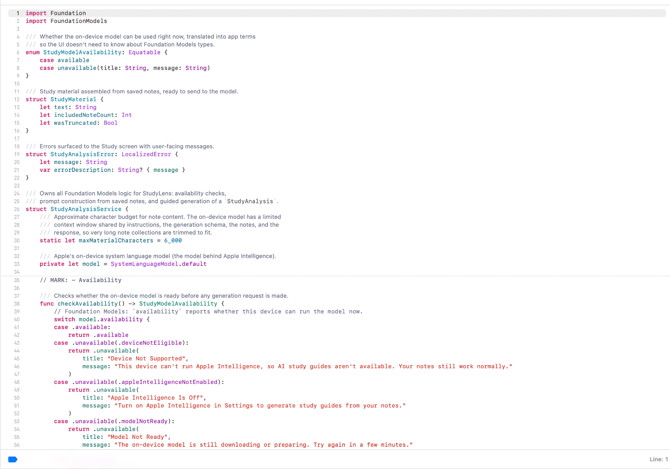
StudyLens uses SystemLanguageModel.default and checks model.availability before generation. The app can explain when the device is not eligible, Apple Intelligence is off, or the model is still preparing. This prevents the study feature from failing without a useful explanation.
The selected notes are combined into clearly marked blocks before generation. I also added a character budget of about 6,000 characters. A fair-share function gives short notes their full text when possible and divides the remaining space among longer notes. That matters when a small handwritten note and a large imported document are studied together.
private static let instructions = """
You are a study assistant that turns a student's notes into a short study guide.
Base everything only on the information in the provided notes.
Do not add outside facts, examples, or details just to make the guide longer.
If the notes do not contain enough information, say that instead of inventing one.
Keep every explanation and answer concise and useful for studying.
"""

A new LanguageModelSession is created for each study guide so an older guide does not remain in the context of a new one. The generation call uses guided generation with StudyAnalysis.self. That lets Foundation Models fill a Swift structure directly instead of returning JSON that I would have to parse by hand.
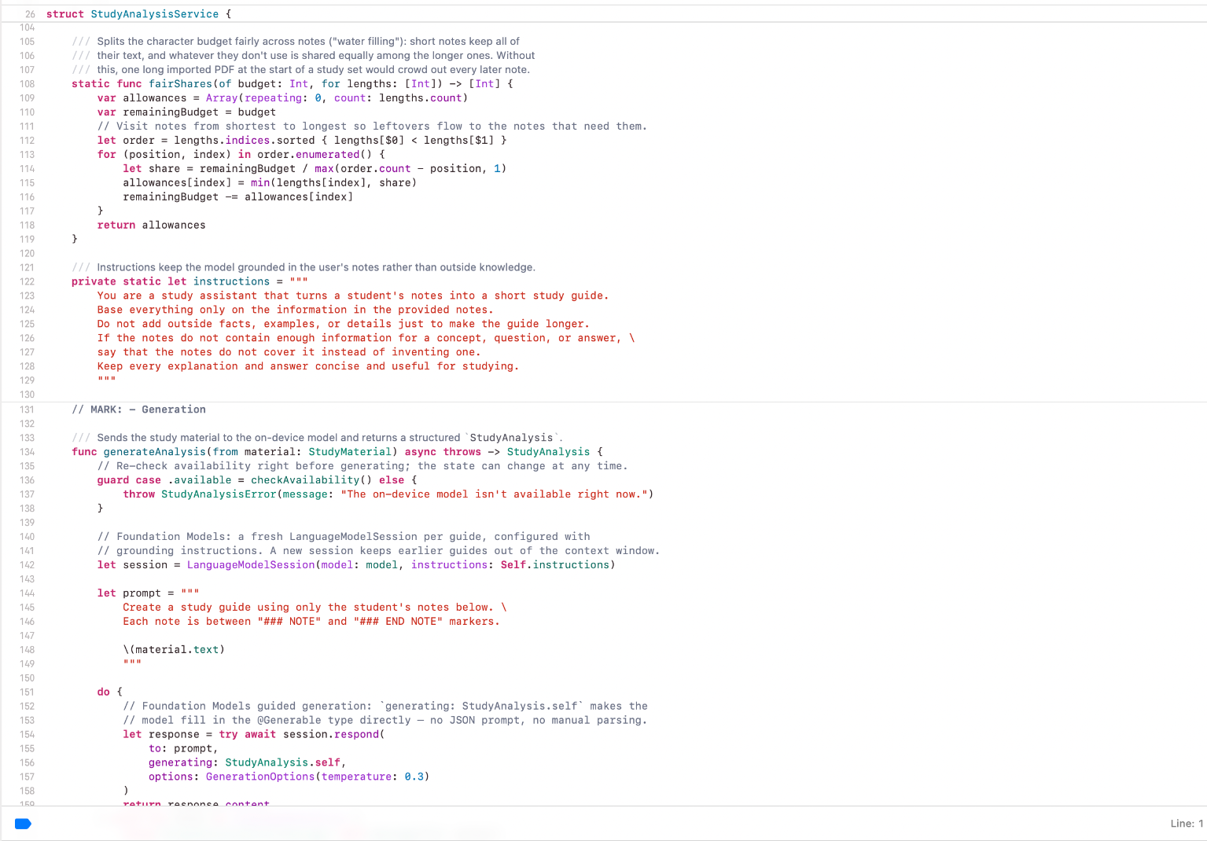
let session = LanguageModelSession(model: model, instructions: Self.instructions)
let response = try await session.respond(
to: prompt,
generating: StudyAnalysis.self,
options: GenerationOptions(temperature: 0.3)
)
return response.content

The resulting StudyAnalysis contains the summary, key concepts, practice questions, and Brain Map data. Quiz Me and Flashcards reuse those generated questions and concepts. Brain Map uses the same generated relationships. This keeps the study tools consistent and avoids unnecessary model calls.
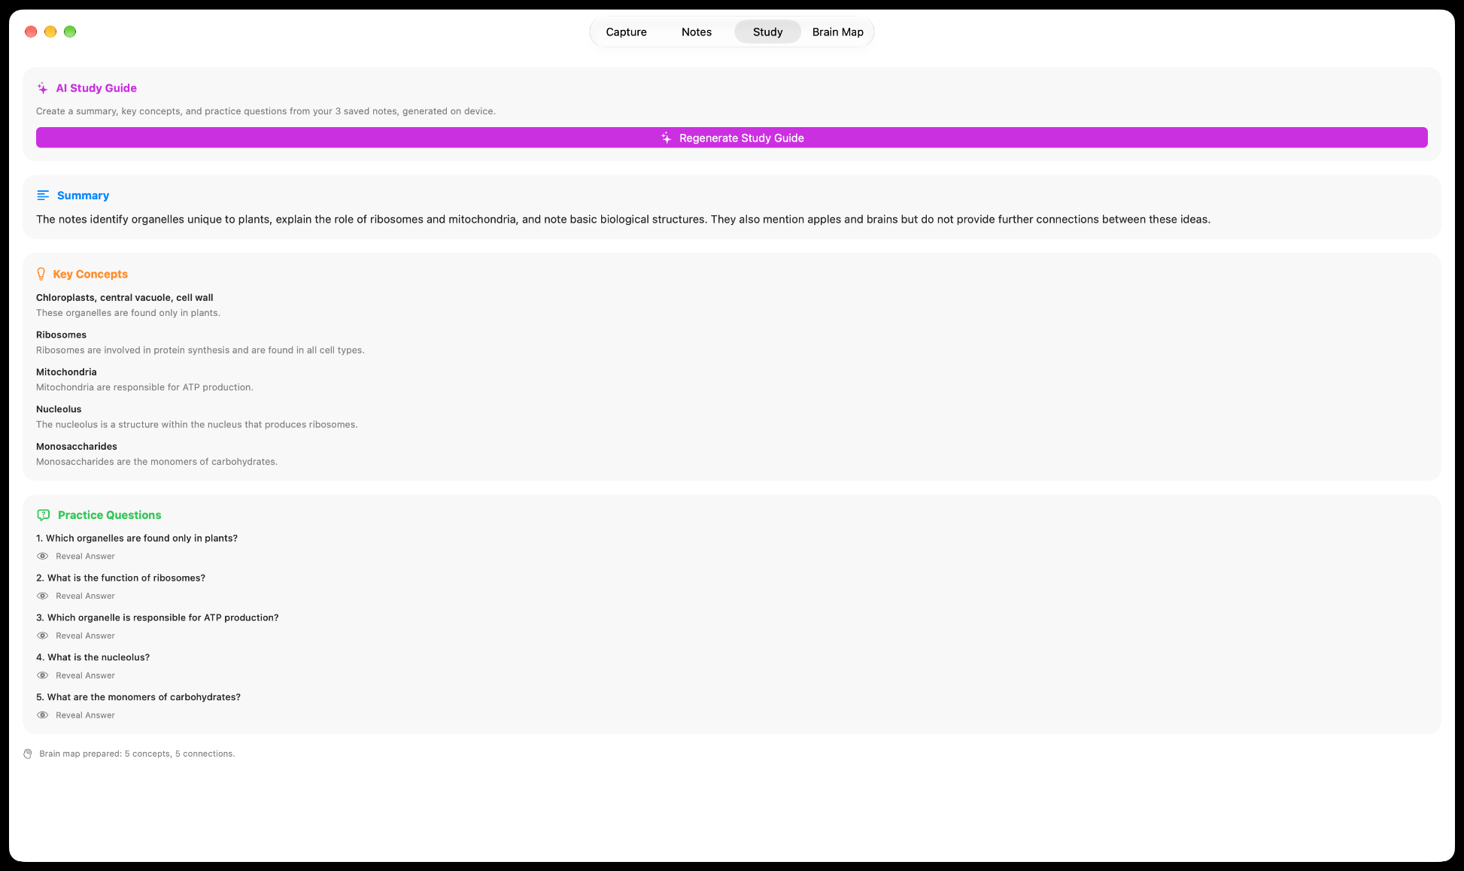

2.2 Vision OCR and Other Input Features
The second major AI-based feature is text recognition with Apple's Vision framework. Scan Image uses VNRecognizeTextRequest to detect text in a selected image. The recognized text is shown in an editable area before saving so OCR mistakes can be corrected. The Write Note feature renders handwriting into an image and sends it through the same Vision service instead of maintaining a second OCR pipeline.
StudyLens also supports voice notes through the Speech framework, text-to-speech through AVFoundation, and file importing for TXT, Markdown, CSV, PDF, images, DOCX, PPTX, and XLSX. Once text is extracted, the source becomes a normal StudyNote and can enter the same study workflow as any other note.
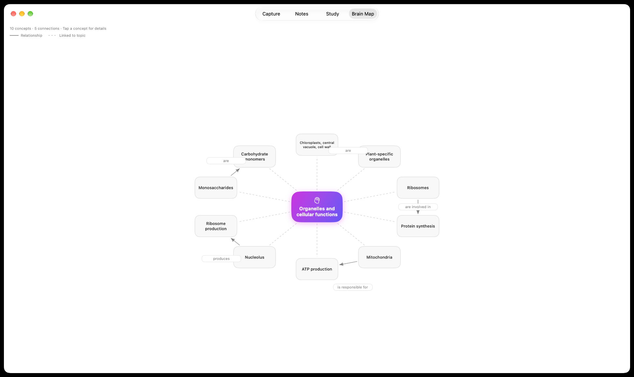

2.3 Wikipedia Enrichment
StudyLens uses the MediaWiki API as an optional external source for Learn More. The lookup is only triggered when the user asks for more information about a concept. The response is decoded into app models, cached for the current session, and kept separate from the active study material. Wikipedia text only becomes part of future study material if the user explicitly chooses Add to Notes.

3. Project Features
The finished app connects several input and review tools through the same saved-note system. A scan, handwritten page, voice transcript, typed note, imported document, or saved Wikipedia article can all become StudyNote objects. From there the user can search, edit, export, and select notes for study.
The Study screen supports All Notes, Selected Notes, and One Note as study sources. A StudySource snapshot records what was used to generate the current guide. If one of those notes changes or is deleted, the guide can be marked as outdated instead of quietly showing old information.
Quiz Me supports typed or spoken answers and uses the same evaluation path for both. When Foundation Models is available, the model can evaluate the response. A local keyword fallback keeps the feature usable on unsupported devices. Flashcards reuse the same generated questions and concepts, with Know It and Review Again ratings, review rounds, read-aloud support, and a session summary.
The Brain Map converts generated concepts and relationships into a deterministic SwiftUI graph. Nodes can be selected for more detail, and Learn More can open Wikipedia enrichment. The map can also be exported as an image or text representation.

4. How I Used Agentic Coding
I used agentic coding as a development partner rather than asking it to build the entire project in one request. I broke StudyLens into stages so I could test one system before adding the next one. The early prompts created the interface, Vision OCR, Foundation Models study guide, Brain Map, handwriting, and voice features. Later prompts added persistence, flashcards, Wikipedia enrichment, navigation cleanup, accessibility work, importing and exporting, and the final audit.
The agent was useful for tracing code across multiple files, generating repetitive support code, checking build errors, and finding interactions that were difficult to notice from one screen. I still had to decide what the app should do, test the UI, compare the result with the assignment, and ask for revisions when the implementation did not match the intended behavior.
A good example was navigation. An earlier version could lose the Study state or return to the wrong place after Flashcards or Speak Note. I described the behavior I wanted, and the agent helped centralize navigation in AppNavigationModel. Another example was the final audit, where the agent inspected the project instead of adding new features and found concrete reliability problems such as a stuck Quiz Me spinner, short-answer grading errors, duplicate DOCX text boxes, malformed XLSX crashes, clipped Brain Map labels, and stale concept-detail screens.
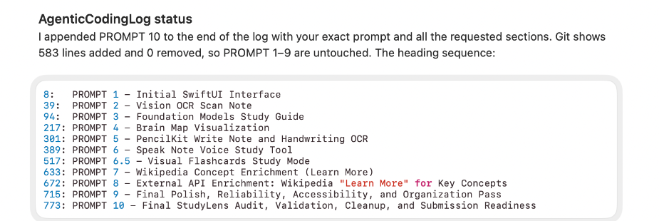
I kept the prompts and results in AgenticCodingLog.txt so the agentic workflow is visible and reviewable. The final Prompt 10 pass was intentionally limited to stabilization, testing, and documentation. It did not add another major feature.

5. Testing and Final Results
The final audit added a DEBUG-only StudyLensSelfChecks.swift file because the project did not have a separate unit-test target. The self-checks use in-memory SwiftData, mocked Wikipedia networking, and temporary files so they do not change the user's real saved notes.
Check | Final result
Logic self-checks | 102 passed, 0 failed
My Mac build | Succeeded, 0 errors, 0 warnings
iPhone 17 simulator build | Succeeded, 0 errors, 0 warnings
Prompt 10 audit | 13 concrete bugs found and fixed
Manual UI testing | Final tap-through completed successfully
The checks covered note search and sorting, navigation duplicate prevention, in-memory persistence, outdated-guide detection, study-source selection, quiz grading, flashcard progress, Wikipedia caching and errors, document importing, exporting, and Brain Map graph logic. I also manually tested the final app flow after the automated checks passed.
The final app still has limits. Foundation Models requires a compatible Apple Intelligence setup. The local Quiz Me fallback does not understand language as well as the model. Study material is trimmed to about 6,000 characters for generation. Generated guides last for the current app session while notes persist. Wikipedia enrichment is English-only and cached only for the session. Legacy Office formats and encrypted or very large Office files are outside the importer scope.

6. Conclusion
StudyLens started as a simple tab-based study app and grew into one connected workflow for capturing material, saving it, generating a grounded study guide, and practicing the result in different ways. The part I consider most important is that the AI does not automatically replace the student's notes. The user chooses what enters the study source, and outside Wikipedia information stays separate unless it is deliberately saved.
The project also gave me experience combining several Apple frameworks in one application instead of treating each framework as a separate demo. Vision, SwiftData, Foundation Models, PencilKit, Speech, AVFoundation, PDFKit, and SwiftUI all contribute to the same study workflow. Agentic coding helped me move through a larger codebase, but the process still depended on testing, clear prompts, and deciding which generated changes actually belonged in the project.

7. References
Apple. (n.d.). Foundation Models framework. Apple Developer. https://developer.apple.com/foundation-models-framework/
Apple. (n.d.). LanguageModelSession. Apple Developer Documentation. https://developer.apple.com/documentation/FoundationModels/LanguageModelSession
Apple. (n.d.). VNRecognizeTextRequest. Apple Developer Documentation. https://developer.apple.com/documentation/vision/vnrecognizetextrequest
Apple. (n.d.). ModelContext. Apple Developer Documentation. https://developer.apple.com/documentation/swiftdata/modelcontext
Apple. (n.d.). PencilKit. Apple Developer Documentation. https://developer.apple.com/documentation/pencilkit/
Apple. (n.d.). SFSpeechRecognizer. Apple Developer Documentation. https://developer.apple.com/documentation/speech/sfspeechrecognizer
MediaWiki. (n.d.). API:Search. MediaWiki Action API documentation. https://www.mediawiki.org/wiki/API:Search/en
Amoo, M. (2026). StudyLens source code and AgenticCodingLog.txt. GitHub. https://github.com/SilentRequiem/StudyLens

